Let’s Talk about Self Sabotage

How those nasty voices kills your chances of success

Worksheets and Homework

Activity Sheets

Worksheet # 1 – “Hopes and Dreams”

Think back to a time in your life when you were optimistic and idealistic. Have this younger version of yourself take a critical look at your present day self and answer the following questions:

- How true to yourself would your younger self think you’ve been in pursuit of your hopes and dreams?

- Complete this sentence: If I could change my life right now, I would…

- Complete this sentence: If my life ended tomorrow, I would regret not having achieved…

Worksheet # 2 – “Character Sketch”
Write a description and draw a character sketch of your Rebel Within from the visualization exercise you just completed.

Physical Characteristics? |  | Skills & Abilities?
Favorite Sayings/Stories? |  | Person or thing? He or she?

In the space below, draw an image of what your Rebel Within might look like, or use the silhouetted figure to draw in its most prevailing features.
Worksheet # 3 – “The Rebel’s Tactics”
Key Notes:

1 - Growth | 2 - Fear | 3 – Doubt | 4 - Lies

Worksheet # 4 – “Who Am I?”
“I am _____________”

How would you fill in the second half of the above sentence? Typically, people first think of the different roles they play in their lives. Here are some common responses:
“I am a father…”  “I am a mother…”  “I am a husband…”  “I am a wife…”  “I am a daughter…” | “I am a son…”  “I am a vegetarian…”  “I am a boss…”  “I am a waitress…”  “I am an athlete…”
Instead of the roles you play, fill in the sentence by thinking of personal traits and characteristics. Brainstorm as many responses as you can think of in the time allotted. Strive for quantity, and don’t censure yourself. Be honest. No one but you will see your answers. Ready? Go!
“I am _________________.” |  |  | “I am _________________.” |  |  |  | “I am ________________.”
“I am __________.” | “I am ___________________.” |  |  |  |  | “I am ___________________.”
“I am _________________.” |  |  |  | “I am _________________.” |  |  | “I am ________________.”
“I am ____________________.” |  |  |  |  | “I am __________________.” |  |  | “I am ____________.”
“I am _________________.” |  |  |  | “I am _________________.” |  |  | “I am _______________.”
“I am ______________.” |  | “I am _________________.” |  |  |  | “I am ___________________.”
“I am _________________.” |  |  |  | “I am __________________.” |  |  | “I am _______________.”
“I am ______________.” |  | “I am _________________.” |  |  |  | “I am __________________.”
“I am __________________.” |  |  |  | “I am _________________.” |  |  | “I am _______________.”
“I am ____________________.” |  |  |  |  | “I am __________________.” |  |  | “I am ____________.”

Worksheet # 5 – “STOP, SPOT and SWAT
the Rebel”

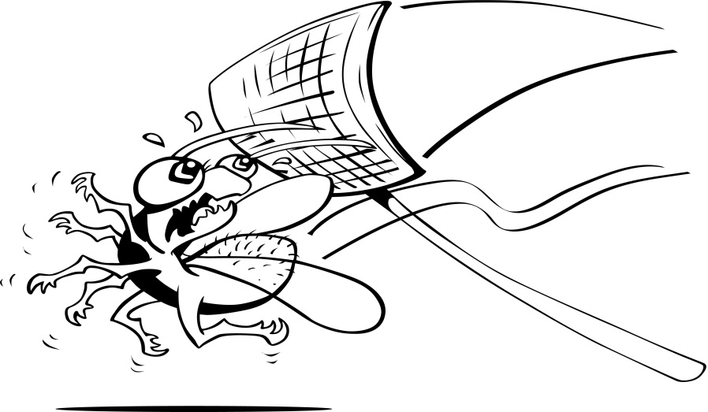

STOP | SPOT | SWAT
Notice the Enemy | Hit the Lie | Reaffirm the Truth
“This is my Rebel Within speaking” | “This is the lie it wants me to believe” | “This is the truth I must remember”

- Think of a situation in your life where you can see your Rebel Within showing up and saying things that make you feel fear in your heart or doubt in your mind. What is this situation (feel free to revisit the lost hope/dream you identified at the start of the call)?

- What is the lie my Rebel Within is telling me around this situation?

- What is the truth around this situation that I can reaffirm and remember going forward?
Worksheet # 6– “One Life Awakened”

- Think of something in your life that you want to change but have been putting off for a while. Write it in the space below.

- Now ask yourself the following two questions around the change you have identified. Don’t think too hard when answering these questions. Just go with your gut response. There are no right answers; it’s just food for thought.

- What will you get if you make this change?

- What will you deprive yourself of if you allow your Rebel Within to keep you from making this change?

- Finally, read the following quote from Steven Pressfield from his book, “Do the Work!” What comes up for you after reading it? Here’s the quote:
“Do it or don’t do it. It may help to think of it this way. If you were meant to cure cancer or write a symphony or crack cold fusion and you don’t do it, you not only hurt yourself, you hurt your children. You hurt me. You hurt the planet. You shame the angels who watch over you and you spite the Almighty, who created you and only you with your unique gifts, for the sole purpose of nudging the human race one millimeter farther along its path back to God. Creative work is not a selfish act or a bid for attention. It’s a gift to the world and every being in it. Don’t cheat us of your contribution. Give us what you’ve got.”

